East Coast City Prayer Walk
Maine Update

Dear Friends of The Ministry Center,
Calvin and Nielsen left for Maine on April 3, 2016, in the middle of a significant wind storm. Following is Nielsen’s account of their experiences and the connections they made while traveling down the Maine coast through April 15…
As we entered Maine, I was immediately drawn to the beautiful ruggedness and open space, the empty highway, the softwood forests and desolate-looking land in between towns and cities, the inlets, marshes and wetland. There was a constant crosswind, blowing at us with strong gusts up to 50MPH. Earlier that morning, as we began our drive, dad had said, “I don’t know if we will, but I want to see a bald Eagle.” Lo and behold, as we neared the end of our drive to Bangor that first day, a large bald eagle soared directly in front of and above us.

The morning of April 8 we met Mel at City Reach Church in town. He’s a 27 year old African American who’s been sober for 2 years, and he runs the recovery house/program. We prayed together and shared our testimonies and then went to the recovery house where 5 men who are in the program are living with Mel. Most of them have recently come out of an addiction or very difficult season of some kind, whether serious drug or alcohol addiction, sexual addiction, family crises, etc. After talking we had a powerful prayer meeting right there in the house. Dad and I were moved at what God is doing through and in these men, some of whom are on fire, and others of whom are still recovering from their past and still figuring out what they even believe.

That night we had the prayer meeting at City Reach Church. It was just a small group of us, including the men from the recovery program, Michael, a Messianic Jew we had met earlier, and another older gentleman from the church. We were prayed over and we prayed over the others, and dad showed and shared about his rod/staff. It was a powerful, blessed night, and we felt such a strong love of God for the men we met who are in recovery, and knew we were there to sow seeds into their lives, even if just for a day.

After our wonderful time in Ellsworth, Bar Harbor, Acadia, and spending time with our new friends at City Reach, we left for Brunswick, a small city near the coast. The morning we left I hiked up Cadillac Mountain while dad prayer walked one last time. We took our time driving Route 1, taking in the beauty of the small towns along the coast. The following story happened on this drive, and I share it because of the profound impact it had on both my dad and I. As we were driving Route 1 along the coast of Maine, we passed a woman along the road, probably in her 20's, using a cane and walking with a prominent limp. Immediately, we both felt an unspoken drawing towards her, and pulled into a gas station just up the road to wait. My dad felt he should give her $5. She turned in toward the gas station (as we thought she might), and we approached her. Her name was Heidi. She stood there, unsure of us at first.

After he had asked her name, my dad began by saying, "That's a beautiful name. You are beautiful. God loves you, and he created you. He formed you in your mother’s womb. Heidi, what do you need?"

She replied, having some difficulty speaking due to her handicap, "I want alcohol."

"That's not going to be good for you. What are you going to do then?"

"Sleep, I guess," she said.

"What should we do?" dad asked as he turned to me. Eventually, we decided to give her the money, and she could do with it as she wanted.
Then, we started to pray for her, and as we did, tears began to well up in her eyes, and her face, her whole countenance, began to beam. We were pouring the love of God upon her. We were speaking value and worth over her.

I said, "You feel God's love, don't you?"

"I don't know," she said, smiling, different.

When we were done praying, she said, "I'm not going into the store. Can you take me back to my home?"

As I drove her back, I asked her, "You weren't expecting this today, were you?"

"No, I wasn't," she replied.

I dropped her off at a large, old, rundown and depressed looking white house. I felt a strong oppression.

As we approached, I said, "You can talk to God and listen to him. He really loves it when we speak to him, and he really loves to speak to us." As she got out I said, "God loves you. We love you.”

"Thank you," she said as she shut the door. "I love you both too."

We never even told her what to do, and she didn't want go into the store for alcohol after we prayed for her. Something changed. Her countenance had initially been downcast when I first saw her. Although she was fairly young, her clothes and appearance were weathered. Looking at her, she had the image of one worn down and fading out, crushed under her physical handicap and the heavy darkness of life. Our hearts literally broke for her, in a way neither my father nor I have rarely experienced; it is hard to put into words.

As we left, my dad and I wanted to cry; we prayed for her. "I just want to take her home," he said with tears.

"Me too," I said, choking up.

Despite where she lived, despite her circumstances, on that day, she experienced the love of the Father. We don't know where she comes from or if she's ever been loved or valued. On that day, she knew she was. We are believing for a new beginning; "from this day forth," we prayed, "she will never be the same."

In Brunswick, ME we connected with Pastors Brad and Trish Mullins at an Assemblies of God church — Elim Community Church — in Bath, only a few miles from Brunswick. We had a wonderful morning at their church, where Calvin shared with the congregation, and we both were able to pray over them. Brad and his family took us to lunch afterward, where we had a nice, long conversation. They’ve pastored quite a few churches going through a recovery (as Elim has been for around a year) after a negative situation or church split. He and his wife have such soft, pastoring hearts and spirits. They’ve been through a lot in ministry, and they told their stories and talked about their testimonies and their past. It was another incredible connection with such wonderful people.

Our last stop was in Portsmouth, NH, right across the water from Kittery, Maine, where we also spent some time. On our first night, we went to the home of Chuck and Carolyn in Kittery, the site of a possible house church plant and also connected with Bonnie and Gary, a couple Dad had connected with at the Dove Leadership Conference at Sandy Cove. Dad shared some of his stories from his previous and current walks, and we had a time of prayer for each other at the end. On our last day, we spent some time exploring the beautiful, historic area in and around Portsmouth and Kittery. The waterfront areas and quaint towns were the perfect way to end our trip.

We finished our first leg of the East Coast City Prayer Walk staying in room number 174. Calvin remembered that John 17:4 says, “I glorified You on the Earth and finished the work that You gave me to do.”

We thank you for your support and prayers--we couldn’t do this without you standing behind us!

Please remember to keep Calvin and Don Lamb in prayer as they travel to MA, RI and CT from May 4-14. If you can contribute financially to help cover the expenses, that would be a tremendous blessing. Don’t forget to check out our web site at www.theministrycenteronline.org to see a lot more pictures from our trip. We would love to hear from you!

Many blessings to you all-

Calvin and Nielsen Greiner

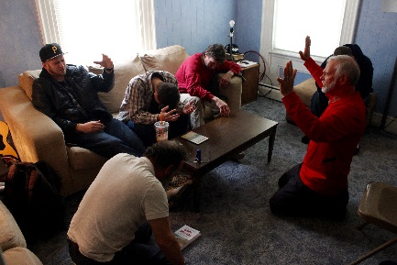

Calvin praying with the men from City Reach Church

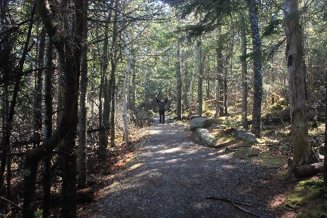

Calvin prayer walking in Acadia National Park

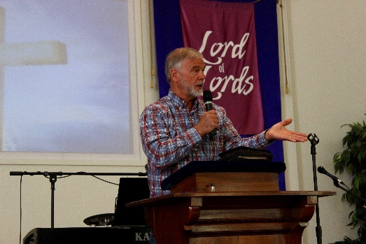

Calvin sharing at Elim Community Church

