April 27, 2015
Dear Friends of The Ministry Center,
Our spring flowers are in full bloom and warm breezes now caress the land after a long, cold winter. Along with the new season, we feel our vision is being infused with Holy Spirit breath as we plan Calvin’s upcoming prayer walks for 2015. During the month of May he plans to walk the city of Harrisburg, followed by Philadelphia in June. We will be recapping our National Cross Walk at Christ Community Church on May 3 and we hope to stir some interest in participating in these city-wide walks. For those of you interested in learning more about prayer walking through a hands-on experience, please contact Calvin since he will holding several group and individual mentoring times during his prayer walks in Harrisburg and Philadelphia.
March 21 we joined a group of dedicated prayer warriors in Mt. Joy, PA. After sending out small groups to strategic points in the town to pray and intercede for an outpouring of God’s Spirit we gathered together to debrief and share what God had showed each one. What a precious time of laboring together in the Lord.
April 10, Calvin and I traveled to Grafton, Massachusetts, where we shared with a wonderful group of women at the Central MA American Baptist Women’s Conference. They were excited to hear our stories and Calvin brought a 90 minute message of encouragement to these hungry hearts. We also had the opportunity to share about our National Cross Walk with Women’s Aglow in York, PA on April 25.
Calvin will share on May 14 and 31 at Oasis, a DOVE church in Akron, PA. Even though we love to share our stories and insights from our National Cross Walk, Calvin’s heart is to walk the streets of towns and cities, carrying the heart and love of God with him wherever his feet tread.
Would you be interested in participating in any of the six prayer walks he has planned from now through October? His tentative schedule through the summer includes: Reading in July, York in August, Baltimore in September and Washington DC in October. We will be sharing details as we firm up dates. Please feel free to contact him with questions and more information. We invite you to sow into this ministry through prayer and financial giving. After seeing the rioting and chaos in the city of Baltimore this week, it is imperative that we have warriors on the front lines of the streets of our regional cities and towns.
We had the launch of our new small group at our home on April 19. We had a wonderful time sharing a meal, fellowshipping and getting to know one another a bit better. The theme for our gatherings is modeled after Acts 2:42, where “we will continue in the Apostles’ doctrine, fellowship, breaking of bread and prayers.” We plan to continue these gathering through the summer. For more information and for meeting dates please contact us.
And now for some family news… our youngest son, Alan, got engaged on March 14 to Danielle (Dani) Forry, a wonderful young lady from Manheim. The wedding is set for next spring, so plans are underway. We are excited to have this godly young woman join our family.
Nielsen, our oldest son, arrived in Nepal just days before the massive earthquake hit April 25. We heard from him briefly a few times and he is fine and planning to continue on with the Annapurna circuit of trekking with the group he is traveling with. We are waiting to hear if he will stay on to help with the restoration and rebuilding process that awaits this needy nation which was devastated by the 7.8 quake. Please keep him and the Nepalese people in your prayers—they have a long road ahead of them.
Do you need some time away from the busyness of life to rest, relax and regroup? Just a quick reminder that our basement apartment is available for personal and couples retreats on select dates. Surrounded by the beauty of Glory Way Gardens, farmland and the quiet beauty of nature, this may the perfect place to get away from it all for a day or two. For more information please contact us!
Before we know it summer will be upon us—vacations, summer holidays, barbeques, swimming and gardening. Remember that God never takes a vacation—He is ever present, ever reaching out to His bride and a world filled with hopelessness and futility. Let’s let our light so shine before men that they may see our good works and glorify our Father in heaven (Matthew 5:17).
Desiring God’s richest blessing to you and yours,
Calvin and Stephanie Greiner, The Ministry Center
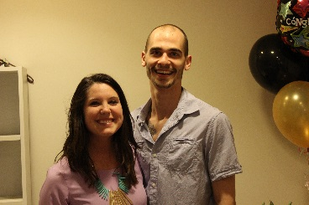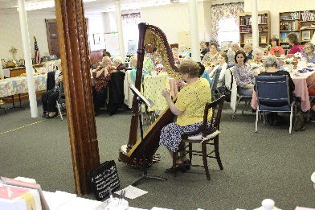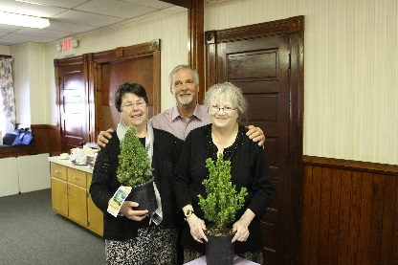
Alan and Dani- Engaged We were so blessed by the Calvin presenting Pam Nielsen
March 14, 2015! amazing ladies at the Central and Pat Downe with pine trees at
MA American Baptist Women’s the conference.
Conference.

